10.3.1 Render - Cycles Render Engine - Introduction
Introduction 1

Introduction

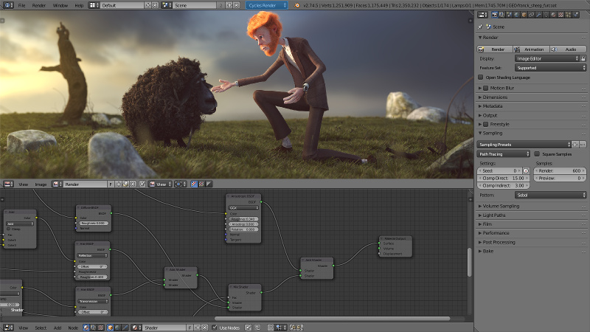
Cycles is a unbiased* ray tracing renderer focused on interactivity and ease of use, while still supporting many production features.
*A unbiased renderer fires rays wildly from the light source until you tell him to stop. It will not stop automatically. But continue to fire rays until you tell him to stop. A biased renderer follows some special algorithms when fiering the rays. And it stops at one point as done. Cycles is a special beast here. It's a unbiased renderer with some bias algorithms to speed things up. This would normally qualify it as a biased renderer. But it still mainly shows the behaviour of a unbiased renderer.
Cycles is bundled as an add-on that is enabled by default. To use Cycles, it must be set as the active render engine. Bforartists comes with Cycles set as the default renderer. Once that is done, interactive rendering can be started by setting a 3D view editor to draw mode Rendered using the render command from the file menu. The render will keep updating as modifications are done, such as changing a material color, changing a lamp’s intensity or moving objects around.
Cycles may be able to use your GPU to render. To see if and how you can use your GPU for rendering, see the documentation on GPU Rendering.
See also
Developer documentation is also available.
http://wiki.Bforartists.org/index.php/Dev:2.6/Source/Render/Cycles

